ABOUT THE MUSICAL
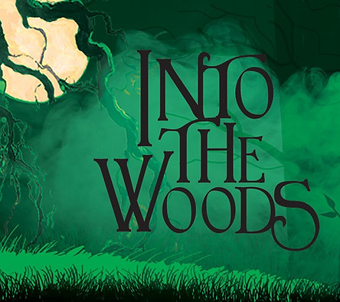
An ambivalent Cinderella? A blood-thirsty Little Red Ridinghood? An unfaithful Prince Charming? A Witch... who raps? They're all among the cockeyed characters in
James Lapine and Stephen Sondheim's fractured fairy tale.
​
The show covers multiple themes: growing up, parents and children, accepting responsibility, morality, and finally, wish fulfillment and its consequences.
“Be careful what you wish for” seems to be the ongoing theme in Stephen Sondheim and James Lapine’s Brothers Grimm inspired musical, Into the Woods. The story follows The Baker and his wife who wish to have a child, Cinderella who wishes to go the King’s Festival, and Jack who wishes his cow would give some milk. When the Baker and his wife are visited by the neighborhood witch, who reveals to them that she placed a curse on their family, the two set off on a journey into the woods to reverse the curse. Also in the woods, we meet Little Red, who is trying to visit her grandmother, the Wolf who loves tasty little girls, the Witch’s daughter Rapunzel, and the Princes chasing after their loves. By the end of Act I, everyone has gotten their wish and will seemingly live happily ever after. But in Act II, when Jack’s beanstalk brings them a visit from an angry Giant, we see how the consequences of their actions haunt them in disastrous ways. The community must come together to save each other and their kingdom, but sacrifices must be made.
​
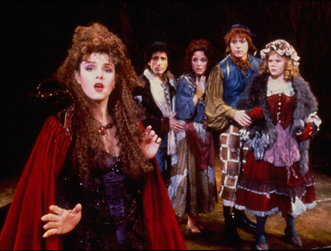
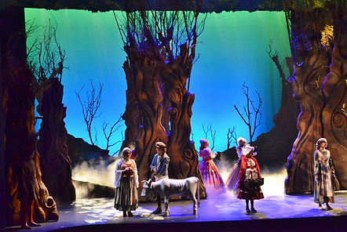
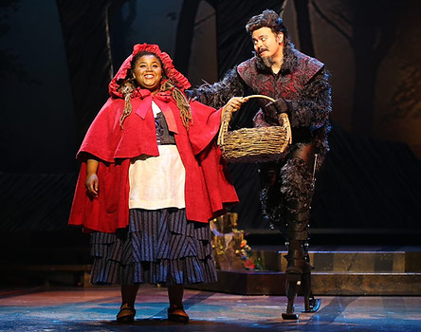
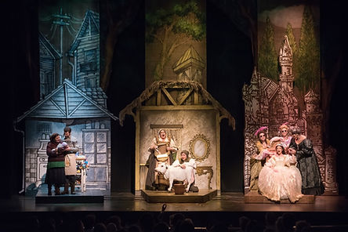
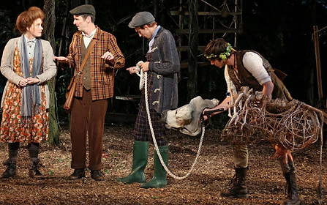
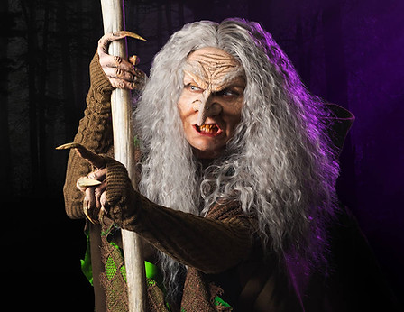
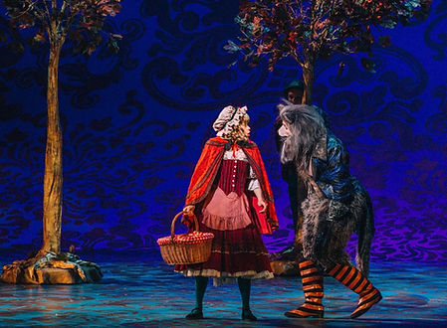
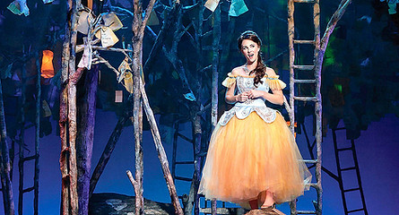

CASTING:
Character Breakdown
​
The Witch
Sarcastic, ugly-then-gorgeous, obsessive protector of Rapunzel who is straightforward and aggressive. On the surface, she is self-serving, possessive, sarcastic, vain, and charismatic. Inwardly, she is insecure and lonely. One of the leading roles with plenty of songs -- a challenging role, strong singing and acting needed.
Age: 45 to 55
Vocal range top: G5
Vocal range bottom: F3
​
The Baker's Wife
An ambitious and clever woman who is determined to be a mother. She leads a simple life, but can be a romantic and materialistic at times. One of the leading roles with several songs. Strong comedic and dramatic acting skills needed.
Age: 35 to 45
Vocal range top: G5
Vocal range bottom: F3
​
Cinderella
A earnest and warm-hearted young maiden who is constantly mistreated by her stepmother and stepsisters. She is a survivor, just trying to find her place in the world. One of the leading roles with several songs. Strong acting and singing skills needed.
Age: 20 to 30
Vocal range top: G5
Vocal range bottom: G3
​
Little Red Ridinghood
A spoiled, clever, vain young girl who is strong-willed. She is also quick-witted and fearless, but because of her age she is naive. She seeks approval in the place of love, of which she has had none. Fun character to play, one of the leading roles with several songs. Strong comedic acting skills needed.
Age: 15 to 20
Vocal range top: F5
Vocal range bottom: Bb3
​
Rapunzel
A loopy-but-lovely maiden who is sheltered by the Witch and terribly lonely. Being locked away, she is completely and utterly innocent of worldly matters. She yearns to experience the world. Needs good vocal control. Strong soprano.
Age: 20 to 30
Vocal range top: A5
Vocal range bottom: B3
​
Jack's Mother
Browbeating and weary, Jack's protective mother who is independent, bold, and strong-willed. As a single mother she's a strong fighter, working hard and determined to make a good life for her hapless son. Older, mid-range female.
Age: 50 to 65
Vocal range top: Gb5
Vocal range bottom: Bb3

​
Narrator
An intellectual and excellent story-teller who relates directly with the audience. He/she helps to orchestrate the show and illustrate lessons to the audience, but can also speak to and interact with the characters.
​Age: any
Vocal range top: E4
Vocal range bottom: G2
​
The Baker
A warm hearted baker who is determined but insecure, and has never faced his fears. He is simple and loving, yet protective of his family. He is willing to do anything to ensure his wife's happiness, but it's hard for him to admit that she is the brains behind the operation. One of the leading roles with several songs. Excellent acting skills needed.
Age: 35 to 45
Vocal range top: G4
Vocal range bottom: Ab2
​
Jack
​The reckless Giant Killer, who is 'almost a man.' He is adventurous, naive, energetic, and bright-eyed. Eager to please and impulsive. A little slow of learning, and misled by his lack of self-knowledge. One of the leading roles with several songs. Strong tenor. Great acting skills needed. A challenging role.
Age: 20 to 30
Vocal range top: G4
Vocal range bottom: B2
​
Cinderella's Prince
Self-dramatizing and endlessly confident. A hero in his own life’s story. Vain and gorgeous, he is a disloyal lover who is currently searching for the next new, exciting thing. One of the leading roles with several songs. Great comedic acting skills needed.
Age: 30 to 40
Vocal range top: F4
Vocal range bottom: B2
​
Rapunzel's Prince
Just as vain and gorgeous as his older brother. Strives endlessly to be beat him in all things. He is also always chasing the newest, most exciting endeavor. His is the more humorous role. Several songs. Strong comedic acting skills needed.
Age: 30 to 40
Vocal range top: E4
Vocal range bottom: C#3
​
Wolf
Hungry and insatiable hunter who takes advantage of the weak by misleading and captivating his prey. Seductive. May wear prosthetics or a mask.
Age: 30 to 35
Vocal range top: Gb4
Vocal range bottom: Bb2
​
Mysterious Man
A mischievous vagrant and nosy meddler... with a secret. He is a good-natured protector and observer. Must be a physical actor, who can move.
Age: 50 to 65
Vocal range top: Eb4
Vocal range bottom: G2
​
​
Cinderella's Mother
Nurturing and loving. She is deceased, but her soul inhabits a tree that Cinderella visits. Her mother's spirit guards and aids her, and dispenses useful advice. Good singing voice.
Age: 40 to 55
Vocal range top: F4
Vocal range bottom: E4
​
Cinderella's Stepmother
The mean-spirited, greedy, demanding stepmother of Cinderella. Superb character part.
Age: 40 to 50
Vocal range top: F#5
Vocal range bottom: A3
​
Florinda And Lucinda
Cinderella's stepsisters who are black of heart. They follow in their mother's footsteps of abusing Cinderella. Loud, energetic. Good character role.
Age: 25 to 35
Vocal range top: Ab5
Vocal range bottom: C4
​
Granny
Bitter and vindictive, she is Little Red's feisty, savage, knife-wielding grandmother. No solo singing, but plenty of humor.
Age: old
​
Giant
(​Female or male) Voiceover. The Giant is a vengeful 'monster' seeking restitution for the murder of her husband. Loud, angry, offstage voice only.
Age: 40 to 60
​
Steward
Accompanies the Prince on his missions. Surly and bureaucratic, full of self-importance. Open vocal range. No solo singing but plenty of good lines.
Age: 20 to 40
​
Cinderella's Father
A drinker, out of touch with his family but harmless and well-meaning. No solo singing. Open vocal range.
Age: 20 to 40
​
​
​
​
​
​
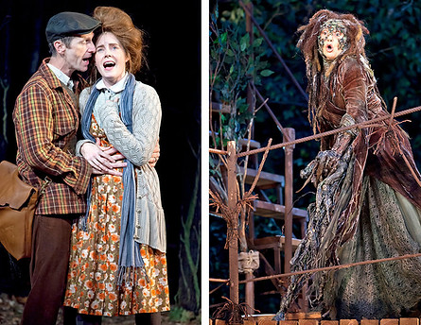

ADDITIONAL INFO
Resources
You should definitely soak in as much as you can - start by watching the PBS Special and begin listening to the Soundtrack!
SHOW HISTORY

Show Premiere
Into the Woods premiered at the Old Globe Theatre in San Diego, California, on December 4, 1986 and ran for 50 performances under the direction of James Lapine. Many of the performers from that production appeared in the Broadway cast as well. The show evolved over its run, and the most notable change was the addition of the song "No One Is Alone" in the middle of the run.
​
Original Broadway Production
Into The Woods opened on Broadway at the Martin Beck Theatre on November 5, 1987, and closed on September 3, 1989 after 765 performances. It starred Bernadette Peters, Joanna Gleason, Chip Zien, Kim Crosby, Ben Wright, Danielle Ferland, Chuck Wagner, Merle Louise, Tom Aldredge, and Robert Westenberg. The musical was directed by James Lapine. The original production won the 1988 New York Drama Critics' Circle Award and the Drama Desk Award for Best Musical, and the original cast recording won a Grammy Award. The show was nominated for ten Tony Awards, and won three: Best Score (Stephen Sondheim), Best Book (James Lapine) and Best Actress in a Musical (Joanna Gleason).
Peters left the show after almost five months due to a prior commitment to film a movie.
In 1989, from May 23 to May 25 the full original cast reunited for three performances to tape the musical in its entirety for the Season 10 premiere episode of PBS’s American Playhouse, which first aired on March 15, 1991. The show was filmed professionally with seven cameras on the set of the Martin Beck Theater in front of an audience.
Tenth Anniversary benefit performances were held on November 9, 1997 at The Broadway Theatre (New York), with most of the original cast. This concert featured the duet "Our Little World," written for the first London production of the show.
On November 9, 2014, most of the original cast reunited for two reunion concerts and discussion in Costa Mesa, California. Mo Rocca interviewed Stephen Sondheim and James Lapine as well as each cast member on stage. Appearing were Bernadette Peters, Joanna Gleason, Chip Zien, Danielle Ferland, Ben Wright and real life husband and wife, Robert Westenberg and Kim Crosby.
​
Revival Production
A revival opened at the Ahmanson Theatre in Los Angeles, running from February 1, 2002 to March 24, 2002.
The 2002 Broadway revival, directed by James Lapine began previews on April 13, 2002 and opened April 30, 2002 at the Broadhurst Theatre, closing on December 29 after a run of 18 previews and 279 regular performances.
Lapine revised the script slightly for this production, with a cameo appearance of the Three Little Pigs restored from the earlier San Diego production. Other changes, apart from numerous small dialogue changes, included the addition of the song "Our Little World," a duet for the Witch and Rapunzel written for the first London production, the addition of a second wolf in the song "Hello Little Girl" who competes for Little Red's attention with the first Wolf, the portrayal of Jack's cow by a live performer (Chad Kimball) in an intricate costume and new lyrics were written for "The Last Midnight," now sung by the Witch as a menacing lullaby to the Baker's baby.
The revival won the Tony Awards for the Best Revival of a Musical and Best Lighting Design.
​
School Adaptation
The musical has been adapted into a child-friendly version for use by schools and young companies, with the second act completely removed, as well as almost half the material from the first. The show is shortened from the original 2 and a half hours to fit in a 50-minute range, and the music transposed into keys that more easily fit young voices.
(NOTE: ACT-1 has done both the full and truncated versions of the musical. We plan to produce the full show and not the school adaptation).
​
Film Adaptation
A theatrical film adaptation of the musical was produced by Walt Disney Pictures, directed by Rob Marshall, and starring Meryl Streep, Emily Blunt, James Corden, Anna Kendrick, Chris Pine, Tracey Ullman, Christine Baranski, Lilla Crawford, Daniel Huttlestone, MacKenzie Mauzy, Billy Magnussen, and Johnny Depp. The film was released on December 25, 2014. It was a critical and commercial hit, grossing over $213 million worldwide. For her performance as the Witch, Streep was nominated for the Academy Award for Best Supporting Actress. The film also received Academy Award nominations for Best Production Design and Best Costume Design.
​
​
Trivia​​​
- In most productions, several parts are doubled. Cinderella's Prince & the Wolf, who share the characteristic of being unable to control their appetites, are usually played by the same actor. Similarly, the Narrator& the Mysterious Man, who share the characteristic of commenting on the story while avoiding any personal involvement or responsibility. Granny & Cinderella's Mother, who are both matriarchal characters in the story, are also typically played by the same person, who also gives voice to the nurturing but later murderous Giant's Wife.
- Stephen Holden wrote that the themes of the show include parent-child relationships and the individual's responsibility to the community. The witch isn't just a scowling old hag, but a key symbol of moral ambivalence. James Lapine said that the most unpleasant person (the Witch) would have the truest things to say and the "nicer" people would be less honest.
- Sondheim drew on parts of his troubled childhood when writing the show. In 1987, he told Time Magazine that the "father uncomfortable with babies was his father, and the mother who regrets having had children was his mother."
- Stephen Sondheim has received eight Tony Awards, more than any other composer in history. He has won seven times.
- The actress who played Cinderella and the actor who played Cinderella's Prince on Broadway met in the original production and then got married in real life.
​

